Chapter 3, Solution 59
i₁
i₂
i₃
4v₀
+
–
– +

96 V
–
+
80V
+
v₀
–

80 Ω
40 Ω
20 Ω
10 Ω
i₂
i₃
I₀
2I₀

For loop 1, -80 + 30i₁ – 20i₂ + 4v₀ = 0, where v₀ = 80i₃
or 4 = 1.5i₁ – i₂ + 16i₃ (1)

For the supermesh, 60i₂ – 20i₁ – 96 + 80i₃ – 4 v₀ = 0, where v₀ = 80i₃
or 4.8 = -i₁ + 3i₂ – 12i₃ (2)

Also, 2I₀ = i₃ – i₂ and I₀ = i₂, hence, 3i₂ = i₃ (3)

From (1), (2), and (3), 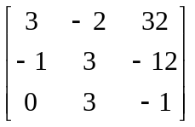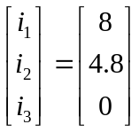

Δ = 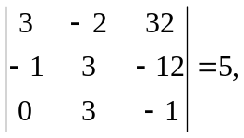 Δ₂ = 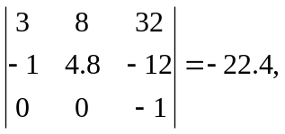 Δ₃ = 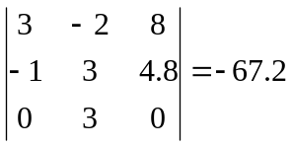

I₀ = i₂ = Δ₂/Δ = -28/5 = –4.48 A

v₀ = 8i₃ = (-84/5)80 = –1.0752 kvolts

